H.T No
Regulations:
A20

Sreenidhi Institute of Science and Technology
(An Autonomous Institution)
Code No: 8B103 Date: 12-July-2021(FN)

B.Tech I-Year I- Semester External Examination, July-2021 (Regular)
ENGINEERING MECHANICS (ME)

Time: 3 Hours Max.Marks:70

Note: a) No additional answer sheets will be provided.
b) All sub-parts of a question must be answered at one place only, otherwise it will not be valued.
c) Missing data can be assumed suitably.

ANSWER ANY 5 OUT OF 8 QUESTIONS. EACH QUESTION CARRIES 14 MARKS.

Bloom's Cognitive Levels of Learning (BCLL)

Remember | L1 | Apply | L3 | Evaluate | L5
Understand | L2 | Analyze | L4 | Create | L6

 |  |  | BCLL | CO(s) | Marks
1. |  | Two identical rollers, each of weight 500N, are supported by an inclined plane making an angle of 30⁰ to the horizontal and a vertical wall as shown in the figure. Evaluate the following:  i) Sketch the free body diagrams of the two rollers.  ii) Assuming smooth surfaces, find the reactions at the support points  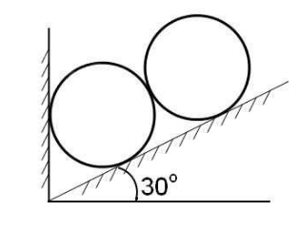 | L5 | CO1 | [14M]
2. |  | Analyze the forces in the all the members of the truss and as shown below figure and tabulate the results.  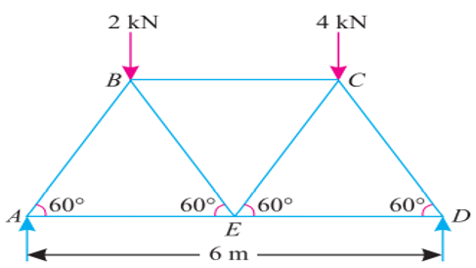 | L4 | CO2 | [14M]
3. |  | Evaluate the least horizontal force P to start motion of any part of the system of three blocks resting upon one another as shown in figure. The weights of the blocks are W_{A} = 300 N, W_{B} = 100 N, and W_{C}= 200 N Between A and B µ = 0.3, between B and C µ = 0.2, and between C and the ground µ = 0.1  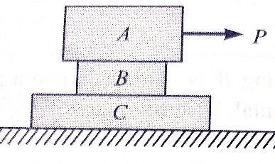 | L5 | CO3 | [14M]
4. |  | Analyze the moment of inertia of the section shown in Fig below with respect to the Centroidal X and Y axes  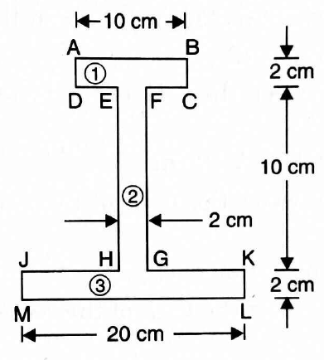 | L4 | CO4 | [14M]
5. |  | A cord runs over two pulleys A and B with fixed axles, and carries a movable pulley C shown in Fig. If P = 40 N, P₁ = 20 N and P₂ = 30 N and cord lies in the vertical plane. Evaluate the acceleration of pulley C. Neglect friction and weight of the pulley.  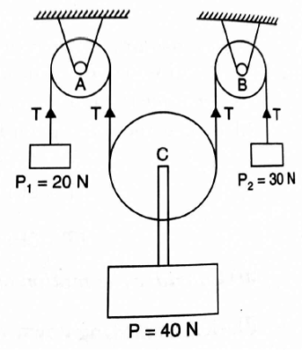 | L5 | CO5 | [14M]
6. |  | Create the constant force P that will give the system of bodies shown in Fig a velocity of 3 m/s after moving 4.6 m from rest.  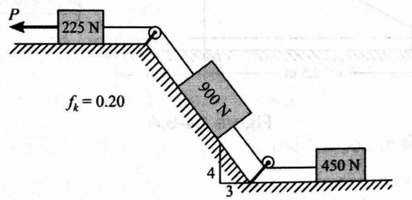 | L6 | CO6 | [14M]
7. | a) | Apply and Determine the resultant of concurrent forces shown in the figure below 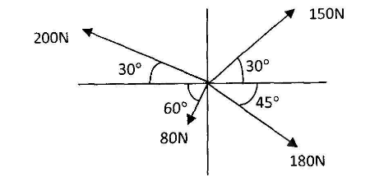 | L3 | CO1 | [5M]
 | b) | Remember and explain principle of virtual work | L1 | CO2 | [5M]
 | c) | Understand the meaning of wedge friction? Mention its applications | L2 | CO3 | [4M]
8. | a) | Evaluate the moment of inertia of a rectangle about its centriod is the same as the M.I. of a triangle about its base | L5 | CO4 | [7M]
 | b) | A stone is dropped from a height. After falling 5 seconds from rest, the stone breaks the glass pane and in breaking the stone losses 20 % of its velocity. Analyze and Find the distance travelled by the stone in the next second. | L4 | CO5 | [7M]

-- 00 -- 00 –

